WARDEN HILL ROAD CHELTENHAM

GL51 3EF

School 01242 235555

Sixth Form Centre 01242 229511 hello@bournside.gloucs.sch.uk [www.bournside.gloucs.sch.uk](http://www.bournside.gloucs.sch.uk/)

**HEADTEACHER**

Mr S Jefferies BA Hons MEd

4th October 2021

**Subject: INVITE - Year 7 School Disco – Thursday 21st October 2021**

Dear Parent/Carer,

Your child is invited to the Year 7 Bournside Disco. This fun event will take place on Thursday 21st October to mark the end of a great first term of the new academic year and the end of CATS assessments. The evening will run from 6pm – 8pm. Bournside staff and a select group of Year 12/13 students from the school Young Enterprise team will be present on the night to supervise the fun event. All students are encouraged to attend as this will be a great opportunity for the year group to get to know each other in a social setting. Please be aware that there will be flashing lights during this event. Students are welcome to bring spending money for snacks.

The cost of the event is £2. Payments are to be made via the School Gateway app on your smartphone, or by using the website at [www.schoolgateway.com](http://www.schoolgateway.com) if you do not have a smartphone. Refreshments will also be available to purchase using cash on the evening.

**Note:** Students will only be allowed to attend on the evening if a fully completed reply slip and medical form has been returned to the school by Friday 15th October. Returned slips after this date will not be accepted.

If you have any questions or queries, please do not hesitate to get in touch via email [lpk@bournside.gloucs.sch.uk](mailto:lpk@bournside.gloucs.sch.uk).

Yours sincerely,

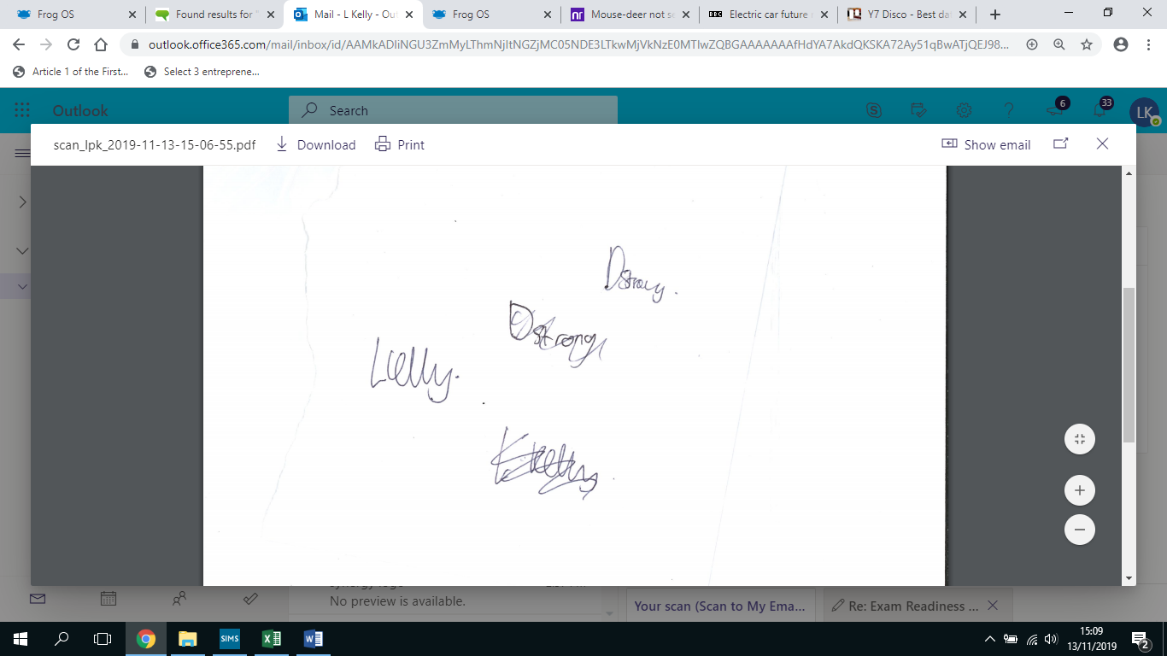

Mr L Kelly

**Head of Business, Economics and Law**

**Reply Slip**: Please return to Admin Services by **Friday 15th October 2021**

# YEAR 7 DISCO – Thursday 21st OCTOBER 2021 - Please return the reply slip and medical consent by 15th October

**Student Name**: ……………………………………………………………….………………… **Tutor Group**: ……………

* I would like my son/daughter to participate in this event and I fully understand that I will need to be present to collect my child from Bournside School at 8pm.
* I agree to pay £2 entry on Student Gateway
* Please tick here if medical information is registered with admin services
* I have completed the medical form and will attach it to the reply slip.

**Note:** Students will only be allowed to attend on the evening if a fully completed reply slip and medical form.

During the event I can be contacted as follows:

🕿………………………...........................................………………………...........................................

**Signed…………………………………………………………….. Date……………………………………………**



**Cheltenham Bournside School and Sixth Form Centre**

**Offsite Visits Personal & Medical Information and Parental Consent Form**

**Trip/Activity**..............................................................................................................

**Departure and Return Dates**............................................**to**........................................................

|  |
| --- |
| **INFORMATION FOR PARENTS/CARERS**  Please complete the questions below and sign. The personal and medical information requested is vital to ensure that appropriate care and support is available for each child. Please consult your family doctor if you are unsure about the suitability of a visit. Medical conditions will not necessarily exclude any child from participating in activities, but leaders should be made aware of anything that might affect the safety/welfare of the student or others in the group*.* |

**Student ....................................... Tutor Group………………… Date of Birth...............................**

|  |  |
| --- | --- |
| **DIETARY INFORMATION**  If he/she has any specific dietary needs (e.g. vegetarian), please give details here: |  |

|  |  |  |  |
| --- | --- | --- | --- |
| **MEDICAL or SPECIAL NEEDS**  **If the student has medical information registered with First Aid, please indicate here**   |  | | --- | | **Nature of condition(s) covered by Individual Healthcare Plan / Medical Information Form:** |   **The School has medical details on record which we ask parents to ensure are up-to-date. Current information is vital for off-site visits and even if a medical information form exists, we must ask you to answer the following questions. Please provide all relevant information which will enable the Visit Leader to care safely for this child:** | | |
| Does he/she have any significant allergies (including to medication)? | **Yes** | **No** |
| Does he/she have any medical conditions, impairments, or disabilities? | **Yes** | **No** |
| Has he/she had any recent significant illnesses or injuries? | **Yes** | **No** |
| If a residential visit, does he/she have any night-time tendencies (e.g. sleepwalking, nightmares) which might cause concern? | **Yes** | **No** |
| **If the answer is “yes” to any of the above questions, please give full details below (use an additional sheet if necessary):** | | |

|  |  |  |  |
| --- | --- | --- | --- |
| **PERSONAL MEDICATION**  It is important that the student has any necessary medication with them and that leaders are fully informed. Please make sure that there is sufficient medication, and that it is clearly labelled. | | | |
| **Name of medication** | **Dosage** | **Time and Frequency or circumstances to be given** | **Method of Administration** |
|  |  |  |  |
| Where will medication be kept?  Please state any special precautions, or side effects (if applicable): | | | |
| **I give my consent\*** for the student to self-administer the above medication and understand that the staff leading the visit are not qualified medical practitioners but they will take reasonable care in the storage of any medication. | | | |

**(*delete as applicable)**

|  |  |  |
| --- | --- | --- |
| To the best of your knowledge, has the student been in contact with any contagious or infectious diseases or suffered from anything in the last four weeks that may be, or become, contagious or infectious? | **Yes** | **No** |
| If yes, please give brief details: | | |
| **Please inform the school should this child be in contact with any infectious illness in the four weeks prior to the visit departure date.** | | |

|  |  |  |
| --- | --- | --- |
| **MINOR MEDICAL TREATMENT**  Young people sometimes need minor medical treatment for conditions such as headaches, rashes, coughs & colds, insect bites, etc. If necessary, with your permission, staff will treat these ailments with the following “off the shelf” products which are commonly available from most chemists:  Paracetamol, throat lozenges, cough mixture, antiseptic cream, calamine lotion, antiseptic wipes, hypoallergenic adhesive plasters, witch hazel, insect bite antihistamine, sun cream. | | |
| Are you willing to allow for this child to be given such products, if required? | **Yes** | **No** |

|  |
| --- |
| **EMERGENCY MEDICAL TREATMENT DURING VISITS**  **I consent** to any emergency treatment necessary. I therefore authorise the Visit Leader(s) to sign, on my behalf, any written form of consent required by the medical authorities should any treatment (a surgical operation or injection) be deemed necessary and if it has not been possible to contact me beforehand. (We will make every effort to contact parents/carers.) |

|  |
| --- |
| **PARENT/CARER DECLARATIONS and CONSENT**   * **I am legally responsible for the care of the student named above.** * **I have listed all relevant medical or other conditions** concerning this student that might affect the duty of care expected during an educational visit. * **I undertake** to inform the Visit Leader (in writing) of any changes in the medical or other circumstances of this student before the date of departure. |

During the visit I can be contacted as follows: 🕿 .....................................................................

Email: …………………………………………………………………..

Signature....................................................................Date.............................................

Name..........................................................................