This document is designed to prepare you for A Level Study.  You will engage with tasks to improve your understanding of the 4 assessment objectives:

**DEVELOPING - EXPLORING - RECORDING - PRESENTING**

At the start of the course you will experience a range of practical workshops and have a go at doing things you haven’t done before.  This will broaden your horizons and enable you to consider more mature possibilities.

Familiarise yourself with the 4 assessment objectives. This is similar to the way you worked at GCSE but for A Level you are expected to work more independently and at a higher level. You will make far more choices about what you do, the way you do it and more importantly be able to demonstrate and explain how your work has developed from a starting point.​​​​​​​

There are 4 sections which correspond to the 4 assessment objectives.

Complete each section in turn and present on PowerPoint, sheets or in a sketchbook after each task.

Each section should take approximately 2 weeks or 6 hours work.

The A level Assessment Grid can be seen below

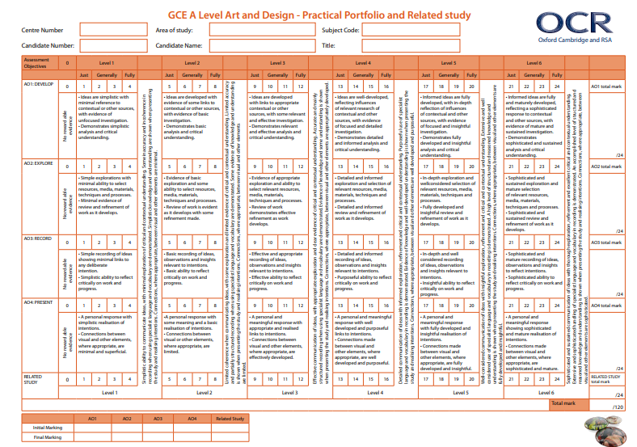

**AO1** = (ASSESSMENT OBJECTIVE 1)

**DEVELOPING IDEAS** **IN RESPONSE TO ‘SOURCES’**

Sources can be artists, a movement, a place, a group of objects, a political message, the list is endless but you must have an initial SOURCE this is your ‘STARTING POINT’

How well can you develop ideas from a starting point?

**TASK 1:**

Here are a range of design styles or different ’STARTING POINTS’, choose one:

Letterpress

Constructivism

Art Nouveau

Psychedelia

Swiss International

Mid Century Modern (Saul Bass)

Dada

Grunge (David Carson)

Research artists and ideas with connections to your chosen design style.

Your research can be in any medium: 2D or 3D (fine art/photography/graphics/ 3D construction or textiles)

For example:-Grunge - Disrupted Text - David Carson - find information about the artist - why does he work in this way? What messages are there in his work? What materials/techniques does he use and why? Why does he create disrupted text? Is his work representational or abstract?

Using the [**Related Study Template**](https://bournside.sharepoint.com/:w:/s/Art-PreALevel-Graphics/EY0rVqvP25tDogD0HQuKLxEBoFgMe08ey6wmt8yQasJagA?e=9DJAl7), write no more than 500 words about what you have discovered. Include information about the artist, an image of their work and some sketches/ notes about how you could develop your own idea based on what you have discovered.  Avoid statements like “I think this is eye-catching” as this is too vague.  Find out what the artist themselves and art critiques say about the work and use quotes to support your written analysis

David Carson for Ray Gun magazine, 1990

[**http://www.davidcarsondesign.com/**](http://www.davidcarsondesign.com/)

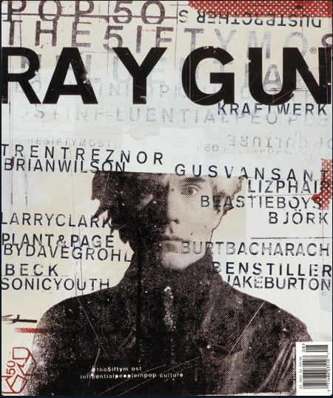

**AO2**(ASSESSMENT OBJECTIVE 2)

**EXPLORING IDEAS, TECHNIQUES AND MATERIALS**​​​​​​​

**TASK 2:-**

Create 3 artworks influenced by your artist study with supporting analysis.

Use subject matter that you have found yourself e.g. Photos or drawings of objects, people, buildings, nature, whatever is appropriate and links to your artist source image.

Use appropriate techniques and materials e.g. Pencil, paint, collage, digital media, construction - card/paper/fabric etc

Annotate to explain how you have made links to the artist or source you chose in AO1 - be critical and avoid statements that explain what you did.  For example:

A low level annotation would be “I have used broken up text because the artist (name) used broken up text”

Instead: A higher level annotation would be “ I have used disrupted fonts and degraded lettering because I can create a design which is not just about reading fonts but more about creating a visual collage of shapes and images that is more closely linked to the style of the artist (name)”.

TAKE IMAGES OF YOUR WORK AND PRESENT ON POWERPOINT OR MOUNTED ON PAPER/CARD

**Record**

**AO3**(ASSESSMENT OBJECTIVE 3)

**RECORDING IDEAS**

Look at how you have recorded your ideas in response to AO1 and AO3.

Are your recordings (drawings/sketches/photographs/paintings/sculptures etc) as good as they can be?  What could you do to improve them - for example are your photographs well lit?  Do your drawings and sketches require more accuracy/contrast in tone?  Do your designs need refining?

Reflect how you can refine and develop your ideas.

What techniques could you use too develop and refine your recordings? Collage?  Photoshop? Scale? Viewpoint? Layering? Duplicating? Distorting?

What would be appropriate and maintain links to the artist you researched in AO1?

**TASK 3:-**Refine your recordings (drawings/sketches/photographs/paintings/sculptures etc) and present 2 different examples of development​​​​​​​.

Take photographs of your work and present them on PowerPoint, mounted on sheets or in a sketchbook.

**Present**

**AO4**(ASSESSMENT OBJECTIVE 4)

**PRESENTING A PERSONAL RESPONSE**​​​​​​​

Reflect on the work you created for AO1, the experimenting you did for AO2 and your refinement and development made to your recordings in AO3.

**TASK 4:-** Create a final piece of work that clearly shows elements from AO1, AO2 and AO3 - this piece of work should be your final refinement.  Annotate your final piece of work explaining how you have made links to the other assessment objectives and the sources you referred to - be critical - try not to be too descriptive.  For a higher level comment on further development possibilities.

FINALLY take a photograph of your FINAL PIECE and present it.